Highland Community Care Forum
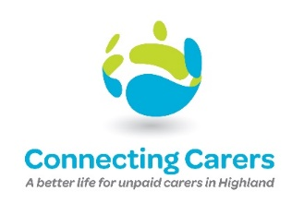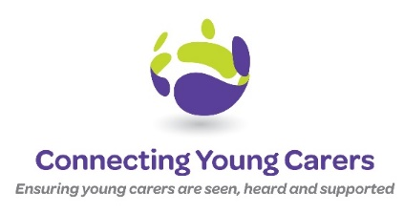
To support Carers in Highland throughout their caring journey

Trustee
Location: Due to Covid-19, meetings are currently facilitated via an online platform with the intention of reinstating face to face meetings when time allows.
Hours: Variable according to the needs of the service. On average, post training, one 2 hour meeting every six weeks plus additional hours associated with specific responsibilities.
Highland Community Care Forum (HCCF) is a vibrant and growing charity committed to supporting unpaid Carers across Highland. Our mission is to support Carers in Highland throughout their caring journey. You can make a difference and contribute to this work.
HCCF is seeking new Trustees. Board Trustees play a critical role in the future development and governance of the service. We would also welcome candidates with a future interest in taking on the role of the Chair.
Working to the organisation’s values, we are seeking a diverse range of Trustees with a commitment to the work we do across Highland.
Impartiality, equality, fairness, passion, and commitment are essential qualities for our board members. We are particularly interested in applicants from less represented groups and those with knowledge and experience of the Third Sector, finance, funding, governance, lived experience of being an unpaid Carer and strategy.
To apply to be part of our Board, please send your CV with a supporting statement to Sarah, HR Officer by email stait@connectingcarers.org.uk
If you have any informal enquiries relating to this opportunity, please contact Roisin Connolly, CEO on 0792 065 3631 or by email rconnolly@connectingcarers.org.uk
The closing date for applications is 11.59pm on Sunday 6 February 2022.
We look forward to hearing from you!

Website link: https://connectingcarers.org.uk/get-involved/become-a-trustee.aspx

