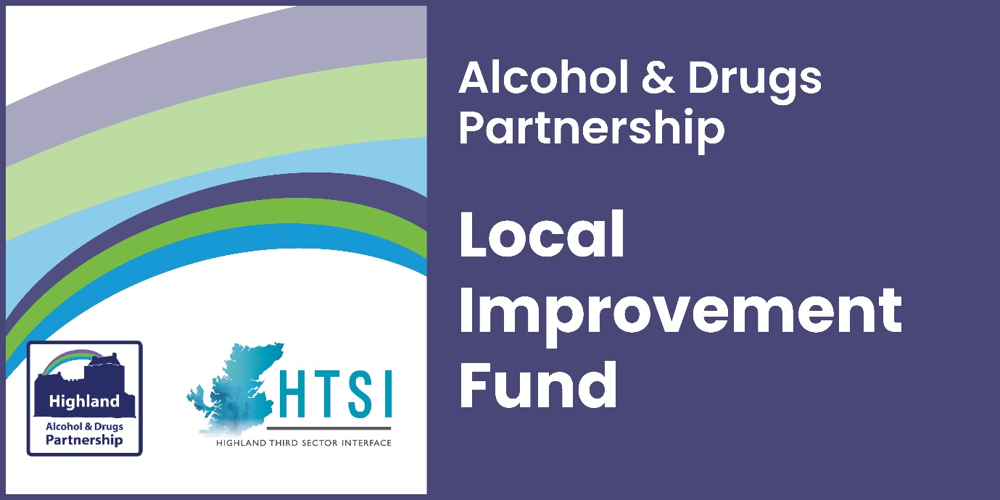

Frequently Asked Questions

We will keep this up to date as further queries come in.
How do I apply?
You can submit an expression of interest through the HTSI website portal. We expect that most expressions of interest will be completed online. Where organisations encounter any barriers, we can accept expressions of interest via an electronic copy using Word, or paper copy. Please contact us if you would like to request an alternative version.
You can only submit a more detailed application for this fund, if invited to do so, after we’ve received and assessed your expression of interest.
When can I apply and when will a decision be made?
Expressions of interest should be submitted between 1 July and 1 August 2022 at 12.00 midday. If you meet the essential criteria, then we will be in touch by the end of August to invite you to submit a more detailed application by the closing date (to be determined). We will also be in touch to let you know if you will not be invited to apply.
Essential criteria:
- In line with Highland ADP strategy
- Previous experience operating or delivering services in the area
- Previous experience working with vulnerable people
- People-led proposals (lived experience shaping the project)
- Clear outcomes for the participants (which will be measured)
What can I apply for?
The range of items you can include in your proposal are wide-ranging, so long as you can provide evidence that endorses the need as well as the proposed activity. You must explain the relevancy and anticipated impacts and outcomes from your activity.
What may I not apply for?
There are only a few activities that will not be considered:
- Contingency costs, loans, endowments or interest
- Electricity generation and feed-in tariff payment
- Political or religious campaigning
- Profit-making/fundraising activities
- VAT you could reclaim
- Statutory activities
- Overseas travel
- Alcohol
Who can apply?
Any constituted third sector organisation who has access to their own bank account and can demonstrate their ability to competently deliver the proposed activities, outlined in their application.
In addition, you (or one of your partners in a collaborative bid) must have experience operating or delivering services in the Highlands and working with vulnerable groups.
How much can I apply for?
The maximum grant in this round of Highland ADP funding is £50,000 per organisation or collaborative bid and this can be spent over one year, or two. You can apply for any amount up to £50,000 but your request should be driven by the actions you want to test, pilot or deliver and the actual cost of delivering it, rather than designing activity to fit the budget.
Grants for up to £5,000 will be on offer in Spring of next year. If your activity is going to exceed £5,000, please submit an expression of interest so that your proposal will be considered in the current round.
When does the activity have to start?
The funding should be awarded by the end of 2022, and we would like to see activity begin on or around 1 April 2023. However, if for any reason you need to delay starting your activity that is fine, so long as it’s not due to run for two years. We aim to be gathering in reports on your activity by March 2025 at the latest, or as soon as you wrap up activities.
When does the funding have to be spent by?
The end date is no later than 31 March 2025. Your activity can run for one or two years, but you must state in your application your proposed timescale.
Am I expected to work in partnership?
The short answer is yes.
You don’t have to submit a collaborative bid, but you will be asked how you are working with groups and other organisations in your area, and you need to make sure you can answer that.
Additionally, it is important that you can describe how people who will benefit from your proposed activities have been involved in designing the activity. We are keen to avoid unnecessary duplication and would encourage you to make sure you explain how you are linking into similar services to provide assurance that it is additional and not duplicating an existing service.
What reporting and evaluation expectations are there?
All projects will have to complete a minimum of a final evaluation report and equality monitoring. The final report will expect you to confirm the actual spend and evidence of change against the outcomes that you outlined in your application.
If your outcomes include work that aims to improve the health and mental wellbeing of participants, we ask that you consider using a wellbeing indicator such as WEMWBS and a physical health question alongside this (see slides for more detail). Please contact us for more information and resources you can use to measure health and wellbeing.
The level of detail should be proportionate to the funding received, meaning the larger your grant sum, we would anticipate a higher level of activity and consequently a higher level of detail.
The lead partner will be responsible for submitting reports as requested. Failure to provide your report on time may influence future funding decisions.
How do you expect us to involve people with living/lived experience?
The local strategy - Rights, Respect, Recovery - acknowledges that people with personal experience of drug and alcohol problems should be meaningfully involved in service and policy development.
You may have people with living/lived experience of drug and alcohol problems among your staff team, volunteers, board of trustees and service participants, who will help to provide you with their perspective on service development. However, we will also be looking for evidence of recent communication with community groups who can help you understand the current issues and views of those who live and work in the area and are affected by substance misuse issues.
It's particularly valuable if you can gather views from those who are not involved in existing third sector support services or action groups, to understand what they perceive to be the gaps. What would encourage them to get involved? You can do this at public meetings, consultation events, focus groups or using surveys (digitally or in person). Perhaps you could work in partnership with your local pharmacy, GP practice or addiction service to deliver surveys to people in your area.
How long will the second stage application take?
The second stage application will take longer to deliberate, as decisions will be made by a panel using a scoring system, to determine who meets the second stage criteria. The panel will select the highest quality applications and award the grant monies accordingly.
Second Stage Criteria:
- demonstrates how the project delivers in line with local strategies and expected outcomes
- demonstrates the need for the project through recent consultation with the community
- demonstrates your ability to deliver change in the community through existing connections/working relationships
- demonstrates an understanding of how community participation can contribute to more successful delivery of the project
- shows how the safeguarding of vulnerable people has been implemented into project planning and delivery
- demonstrates how you will measure change in individuals and/or the community, proportionate to the size of the grant you are requesting
- demonstrates how you will measure inclusion of people with protected characteristics, reflecting the community you serve
- shows that consideration of fair work practices has been included in the project proposal, including how to overcome current recruitment challenges, with indicative costs
- demonstrates that environmental impact is considered and plans to mitigate it have been described

Who is on the funding panel?
The panel is made up of members of Highland Alcohol & Drugs Partnership, people with living/lived experience and other people with first-hand experience of the relevant issues in Highland, including colleagues from third sector.
When will a decision be made?
We aim to have awarded the grants of up to £50,000 and notified all applicants of the decision by the end of 2022 at the latest.
Once a decision is made, when will the grant be paid?
If your application is successful, you will be asked to complete a funding agreement. The grant will be paid within two weeks of HTSI receiving the completed funding agreement from you.

