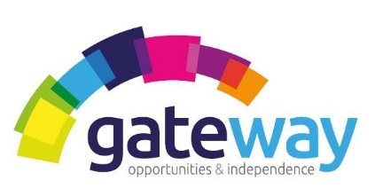

RESPECT|CARING| TRUST| EMPATHY| RELIABLE

We are currently seeking to recruit Full & Part Time Support Workers to join our team in Invergordon.

Position: Full and Part Time (day & night shift)
Shifts: Various
Salary: £20,748 - £21,340. p.a. pro rata (based on 38 hours per week)

Role of the Support Worker
- Provide holistic support to a female client Jane to live in her own tenancy to help her achieve her goals. Jane has multiple and complex needs and can often display behaviours that challenge.
- Support Jane to take prescribed medication, personal care tasks, access activities, spend time in the community, attend health appointments, carry out household chores and preparing meals.
- Provide comprehensive support planning service to Jane in line with the Gateway policies, procedures and approach.
- Set up and maintain files and ensure that accurate and up to date records are kept of support provided to Jane in accordance with Gateway policies.

Experience & Requirements
- Experience: Previous experience and understanding of Mental Health, learning disabilities and challenging behaviour would be advantageous but not essential as full training and mentoring will be provided before starting in the role.
- Understanding of Safeguarding adults.
- Knowledge and understanding of up to date legislation, government frameworks relevant to the client group.
- Ability to communicate effectively in writing including the preparation of reports & file notes.
- Personality: You should have a positive attitude and patience together with good verbal and written communication skills.
- You will be a team player and may help provide support flexibly to the service
- Our Values: It’s vital that you align to our company values.

What do Gateway have to offer you?
- Full Time and Part Time contracted hours.
- Mileage allowance for using your own vehicle.
- Fully paid induction training, including shadowing and mentoring.
- Ongoing training and support.
- Work Pension Scheme.
- Fully paid PVG membership.
- The opportunity to sign up to Charity Workers discount scheme, Blue Light Card and Discount for Carers schemes.

About Gateway
Gateway is a Charitable Organisation established in 1998, that has a Gold Investors in People award. Our goal is to support vulnerable people in our community. Our aim is to provide a range of high-quality care services and activities that improves the well-being of the vulnerable people we support we achieve.

All positions require successful applicants to be a member of the Protecting Vulnerable Groups (PVG) Scheme and undertake the necessary vetting checks. Gateway implements an equal opportunity policy to promote diversity, however, this position is only open to female applicants only as being female is deemed to be a genuine occupational requirement under Schedule 9; Paragraph 1 of the Equality Act 2010.

For further an informal chat about the role please contact Rachel Barry, Service Manager on 07595851418 or for an application pack, please contact Clare Netherton, Administrator on 01463 718693 or email clare.netherton@homelesstrust.org.uk

http://www.homelesstrust.org.uk
Charity Number: SC02883

