Highland Community Care Forum
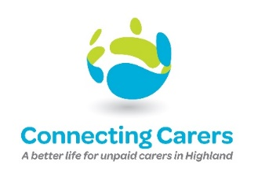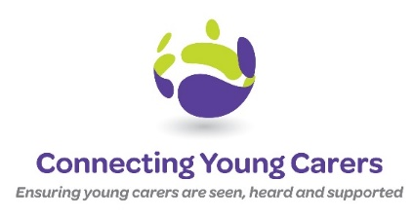
To support Carers in Highland throughout their caring journey

Wellbeing Officer
Vacancy Reference: WB001
Location: Our Organisation delivers a blended model of support to unpaid Carers throughout Highland. The post holder will be located at their home covering Highland
Hours: 28 hours per week
Salary: £26,000 pro rata per annum
Contract: Fixed Term up to the end of January 2024
Funded by the Big Lottery Community Fund, Connecting Carers are very excited to be developing a new service to enable unpaid Carers to have the space, time and dedicated support to truly be listened to in a non-judgemental manner supported by a team of Wellbeing Officers.
The aim of the service is to listen and support all unpaid Carers from the age of 8 to self-manage their caring role, in a way that does not impact negatively on their health and wellbeing and that of the cared for person. This listening service will bridge the support between our existing counselling service and the role of the Carer Link Worker.

We are seeking a team player who has, the following values, empathy, respect, integrity and caring. You must be passionate about what we do, how we do it and our commitment to supporting unpaid Carers throughout Highland.

If this, is you, we would love to hear from you!

If you have any informal questions about the role, please contact Mary, our Business Development Officer on 0742 369 2556 or mcook@connectingcarers.org.uk

To apply for this role, please visit our website to download the job description and person specification along with our application form and return your completed application to Sarah, HR Officer by email stait@connectingcarers.org.uk
Closing date for applications is 11.59 pm Sunday 28 August, with a view to holding interviews week commencing 5 September 2022.
Website link:

